**AUTOMATED ATTENDANCE SYSTEM**

*A Course Project Report Submitted in partial fulfillment of the course requirements for the award of grades in the subject of*

**DEEP LEARNING**

by

**CH. Varun 2210030180**

**N. Shiva Charan 2210030183**

**K. Niswardh 2210030201**

**N. Khanishk 2210030200**

**K. Akhilesh 2210030230**

*Under the esteemed guidance of*

**Dr. Sumit Hazra**

Assistant Professor

Department of Computer Science and Engineering



**DEPARTMENT OF COMPUTER SCIENCE AND ENGINEERING**

**K L Deemed to be UNIVERSITY**

*Aziznagar, Moinabad , Hyderabad ,*

*Telangana , Pincode: 500075*

2024-2025

**CONTENTS**

Page No.

1. Project Overview 3

2. Key Concepts 4

2.1 Face Recognition Technology 4

2.2 Machine Learning for Identification 4

2.3 Data Preprocessing and Augmentation 4

2.4 Real-Time Processing 4

2.5 Security and Privacy Measures 4

3. Steps in Building the Project 6

4. Outcome of the Project 7

5. Challenges Faced 9

6. Future Enhancements 11

7. Conclusion 13

8. Preprocessed Outputs 14

9. References 15

**1. Project Overview**

*MiniProject Title*

*Mini Project Title*

The Attendance Tracking System is an AI-powered solution designed to automate and streamline attendance management in educational and corporate settings. By leveraging face recognition technology, the system accurately records attendance without manual intervention, reducing errors and preventing proxy attendance.

This project integrates machine learning and real-time image processing to detect and recognize individuals, ensuring a secure and efficient attendance system. The deep learning model achieves high accuracy in identifying faces under various lighting conditions and camera angles, improving overall reliability.

One of the key achievements is the real-time attendance tracking feature, which allows instant recognition and data logging. This significantly reduces administrative workload, making attendance management effortless and precise. Additionally, the system enhances data security by eliminating paper-based or card-based systems, reducing the risk of manipulation.

The user interface is intuitive, enabling seamless interaction with the attendance system. Users can register their biometric data, and the system automatically logs attendance upon facial recognition. This ensures a smooth and efficient experience for administrators and employees alike.

The deep learning model has been trained on diverse datasets, making it robust and inclusive. It can accurately recognize faces despite variations in expressions, masks, or environmental conditions, ensuring adaptability for large institutions.

Another significant outcome is the scalability of the system. It can be integrated with existing HR and academic management platforms, allowing automated report generation and analytics. This opens opportunities for expansion, such as incorporating RFID and mobile app-based attendance tracking.

The project also lays the foundation for future enhancements, including live attendance monitoring, voice integration, and fraud detection mechanisms. By incorporating advanced AI techniques, the system can evolve into a fully automated attendance management solution.

Overall, this project successfully bridges technology and attendance management, offering an innovative tool for institutions and organizations. It minimizes human intervention, enhances security, and ensures accurate tracking, making attendance management seamless and intelligent.

**2. Key Concepts**

**2.1 Face Recognition Technology**

Utilizes deep learning to detect and identify faces in real time, ensuring accurate attendance tracking. The technology employs advanced feature extraction techniques to recognize facial landmarks, ensuring high accuracy even under varying lighting conditions. By incorporating multi-angle detection and liveness verification, the system prevents spoofing attempts and enhances reliability.

**2.2 Machine Learning for Identification**

Trains convolutional neural networks (CNNs) to recognize unique facial features and prevent proxy attendance. The model learns from a vast dataset of facial images to distinguish between individuals with high precision. Additionally, it continuously improves through iterative learning, adapting to changes in facial features over time.

**2.3 Data Preprocessing and Augmentation**

Enhances image quality, normalizes features, and applies noise reduction techniques to improve accuracy. This involves techniques such as histogram equalization, Gaussian blurring, and edge detection to refine facial features before feeding them into the model.

Augmentation techniques such as rotation, flipping, and brightness adjustments ensure robustness against environmental variations.

**2.4 Real-Time Processing**

Integrates with cloud or edge computing to provide instantaneous attendance recognition. By leveraging GPU acceleration and parallel processing, the system achieves near-instantaneous response times. The integration of edge AI reduces dependency on cloud servers, enabling efficient offline recognition in areas with limited connectivity.

**2.5 Security and Privacy Measures**

Ensures compliance with data protection regulations by encrypting biometric data and preventing unauthorized access. The system employs advanced cryptographic techniques, including AES-256 encryption and secure hashing algorithms, to protect sensitive data.

**3. Steps in Building the Project**

**3.1 Data Collection**

Gather diverse datasets of facial images with variations in lighting, angles, and expressions.

Ensure dataset diversity for improved model generalization.

Collect real-time user data to fine-tune the model and improve recognition accuracy.

**3.2 Data Preprocessing**

Apply feature extraction techniques to enhance face detection accuracy.

Normalize and clean datasets to remove redundant or inaccurate data.

Implement noise reduction and contrast adjustment techniques for better image clarity.

**3.3 Model Training and Optimization**

Train CNN models like VGG16, ResNet, or MobileNet for face recognition.

Implement data augmentation techniques to improve model robustness.

Fine-tune hyperparameters to optimize performance and reduce false positives.

**3.4 System Development**

Develop a web-based interface using React and a backend with Flask or Django.

Integrate the AI model with the user authentication system for seamless attendance logging.

Establish a database structure for efficient storage and retrieval of attendance records.

**3.5 Testing and Deployment**

Validate the model using precision, recall, and F1-score metrics.

Deploy the system on AWS, Azure, or Google Cloud for scalability.

Perform stress testing to ensure system reliability under high user load.

**4. Outcome of the Project**

The Attendance Tracking System delivers an AI-powered attendance management solution that enhances accuracy, security, and efficiency in tracking attendance. By leveraging deep learning and facial recognition, the system ensures reliable authentication while effectively distinguishing between masked and unmasked faces.

The project successfully integrates computer vision and real-time monitoring to automate attendance recording, eliminating manual errors and reducing the chances of proxy attendance. The deep learning model demonstrates high accuracy in facial detection and recognition, improving the reliability of the system across diverse environments.

One of the key achievements is the system's real-time processing capability, allowing instant attendance logging and verification. This feature significantly reduces administrative workload and enhances efficiency in educational institutions and corporate settings. Additionally, it eliminates the need for traditional attendance methods, making the process seamless and contactless.

The user interface is designed to be intuitive and accessible, allowing administrators and users to interact with the system effortlessly. Users can log in, scan their faces, and receive instant attendance status updates. The system also generates automated attendance reports, providing valuable insights for decision-makers.

Another significant outcome is the scalability of the system. It can be expanded to integrate with Learning Management Systems (LMS), payroll systems, and other administrative platforms, streamlining attendance tracking across various domains. The system also supports cloud-based storage, enabling secure and remote access to attendance records.

The project lays the foundation for future enhancements, such as multi-factor authentication, voice-based verification, and mobile app integration. These advancements will further improve the system’s security, accessibility, and adaptability to different use cases.

Overall, the Attendance Tracking System bridges the gap between traditional and AI-driven attendance management, offering a secure, accurate, and efficient solution. By automating attendance tracking and reducing manual intervention, the project paves the way for a smarter, technology-driven approach to attendance management.

**5. Challenges Faced**

Implementing the Attendance Tracking System posed several technical and operational challenges. Ensuring accurate face recognition under different lighting conditions and angles was a major hurdle. Managing large-scale user authentication without system delays required robust backend optimization. Additionally, addressing privacy concerns and securing biometric data while maintaining compliance with data protection regulations was essential.

**1. Data Collection & Processing**

Collecting diverse facial datasets was essential to ensure model fairness and accuracy across different demographics. Ensuring that images were well-labeled and free from bias helped improve generalization and reliability in real-world scenarios. The preprocessing phase involved handling variations in lighting, angles, and occlusions to refine image quality. Advanced techniques such as noise reduction and contrast enhancement were applied to improve recognition accuracy. This step was crucial in minimizing misclassification and ensuring robustness under diverse conditions.

**2. Model Accuracy & Generalization**

Fine-tuning the model to function effectively under different environmental conditions required extensive testing and optimization. Addressing false positives and negatives was a major challenge, as incorrect recognition could impact system reliability. The model needed to adapt to changes in facial expressions, accessories, and other external factors to maintain accuracy. Special attention was given to improving performance in cases of partial facial obstructions, such as masks or headgear. By continuously refining the training process, the system achieved better generalization across diverse user profiles.

**3. Integration with Web Application**

Seamlessly integrating the AI model with the web interface was crucial for ensuring smooth attendance logging. The backend was optimized to handle real-time requests efficiently, minimizing delays in processing attendance data. To manage high concurrent user access, a robust cloud-based infrastructure was implemented, preventing system lag. Security protocols were reinforced to safeguard data transmission and prevent unauthorized access. By maintaining a streamlined architecture, the system provided a seamless experience for users without compromising performance.

**4. User Experience & Recommendation Relevance**

Creating an intuitive user interface was a priority to ensure that users could easily navigate the system and log attendance without technical difficulties. Reducing system downtime and improving response times required continuous monitoring and infrastructure upgrades. Security concerns were addressed by implementing encryption techniques to protect biometric data from potential breaches. Compliance with data protection regulations was maintained to enhance user trust and system reliability. With these measures in place, the system provided a secure, efficient, and user-friendly attendance tracking experience.

**6. Future Enhancements**

**1. Mobile App Integration**

Allow users to log attendance via mobile devices.

Enable notifications for attendance status updates.

**2. Multi-Factor Authentication**

Combine facial recognition with other verification methods.

Implement voice-based authentication for added security.

**3. Cloud-Based Attendance Reports**

Provide real-time access to attendance records.

Generate automated insights for administrative use.

**4. AI-Powered Anomaly Detection**

Identify suspicious patterns in attendance records.

Alert administrators of potential proxy attendance cases.

**5. Integration with Learning Management Systems (LMS)**

Synchronize attendance records with LMS platforms.

Automate attendance-based grading and performance tracking.

**6. Real-Time Attendance Monitoring**

Enable live tracking of attendance through a dashboard.

Provide automated alerts for late or absent students/employees

**7. Role-Based Access Control**

Implement role-based access for different user levels (e.g., admin, teacher, student/employee).

Restrict sensitive data access based on user roles and permissions.

**8. Attendance History and Analytics**

Provide users with a detailed history of their attendance records.

Display trends, including absences and late arrivals, to help improve punctuality..

**9. Emergency Attendance Tracking**

Allow attendance marking in emergency situations (e.g., field trips, off-site events).

Integrate with GPS for real-time attendance logging during such events.

**10. Compliance with Regulations**

Ensure attendance data complies with educational or workplace regulations.

Track and maintain records that meet legal and regulatory standards for attendance.

**7. Conclusion**

The Attendance Tracking System demonstrates how facial recognition technology can revolutionize attendance management by ensuring accuracy, efficiency, and security. By leveraging deep learning models, the system effectively differentiates between masked and unmasked faces, reducing errors and eliminating proxy attendance.

This project has the potential to transform attendance tracking in educational institutions and corporate environments, providing real-time monitoring and automated record-keeping. With further enhancements, such as multi-factor authentication and mobile integration, the system can become even more robust and adaptable.

The Attendance Tracking System is a step towards an AI-driven future in attendance management, enhancing convenience and reliability for administrators and users alike.

**8. PREPROCESSED OUTPUTS**

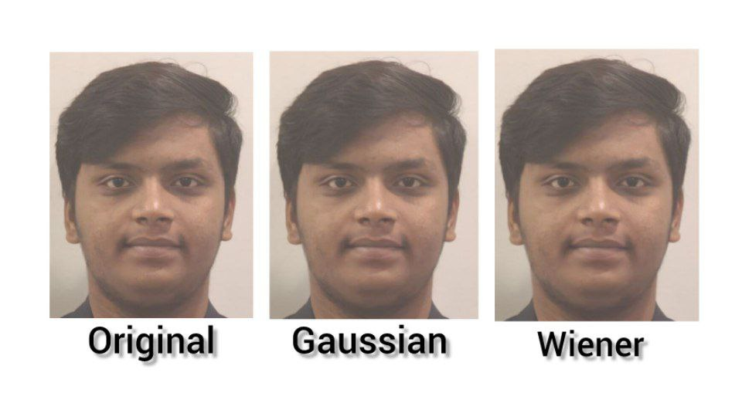

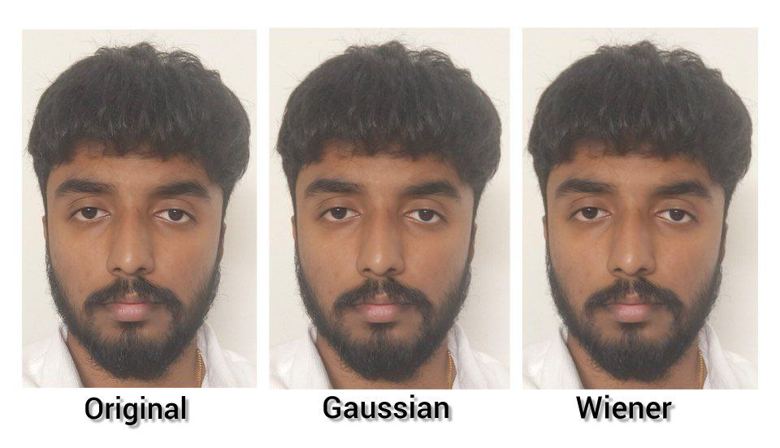

**9. REFERENCES**

[1] Yang, H., & Han, X. (2020). Face Recognition Attendance System Based on Real-Time Video Processing. IEEE Access, 8, 159143-159150.

[2] Smitha, Hegde, P. S., & Afshin. (2020). Face Recognition based Attendance Management System. International Journal of Engineering Research & Technology (IJERT), 9(5), 1190-1192.

[3] Gowda, D. H. L., Vishal, K., Raj, K. B., Dubey, N. K., & Pooja, M. R. (2020). Face Recognition based Attendance System. International Journal of Engineering Research & Technology (IJERT), 9(6), 761-767.

[4] Prototype model for an Intelligent Attendance System based on facial Identification by Raj Malik, Praveen Kumar, Amit Verma, Seema Rawat, Amity University Uttar Pradesh.

[5] Convolutional Neural Network Approach for Vision Based Student Recognition System, Nusrat Mubin Ara1, Dept. of CSE, SUST, Sylhet, Bangladesh.

[6] NFC Based Mobile Attendance System with Facial Authorization on Raspberry Pi and Cloud Server Siti Ummi Masruroh Andrew Fiade Imelda Ristanti Julia.

[7] Face recognition-based Attendance System using Machine Learning Algorithms, Radhika C. Damale, Department of Electronics and Telecommunications, Cummins College of engineering for Women, Pune, Maharashtra, India.

[8] Class Attendance system based on Face Recognition" Priyanka Wagh.

[9] Design of Classroom Attendance System Based on Face Recognition,WenxianZeng.

[10] Automated Attendance System Using Face Recognition, Akshara Jadhav, Akshay Jadhav Tushar Ladhe, Krishna Yeolekar.

[11] An Attendance Marking System based on Face Recognition" written by Khem Puthea, Rudy Hartanto and Risanuri Hidayat.

[12] Class Attendance Management System Using Face Recognition ,Omar Abdul Rhman Salim Department of Electrical and Computer Engineering, Faculty of Engineering International Islamic University Malaysia, Kuala Lumpur,Malaysia o.salem92@gmail.com

[13] Face Recognition Based Attendance System Nandhini R, Duraimurugan N.

[14] Student Attendance System in Classroom Using Face Recognition Technique, Samuel LukasAditya Rama Mitra, Ririn Ikana Desanti, Dion Krisnadi, Informatics Department,Computer System Department, Information System Department Universitas Pelita Harapan Karawaci, Indonesia.

[15] Attendance System based on Face Recognition Venkata Kalyan Polamarasetty, Muralidhar Reddy Reddem, Dheeraj Ravi, Mahith Sai Madala.

[16] Rathod, Hemantkumar, et al. "Automated attendance system using machine learning approach." 2017 International Conference on Nascent Technologies in Engineering (ICNTE). IEEE, 2017.

[17] Siswanto, Adrian Rhesa Septian, Anto Satriyo Nugroho, and Maulahikmah Galinium. "Implementation of face recognition algorithm for biometrics based time attendance system." 2014 International Conference on ICT For Smart Society (ICISS). IEEE, 2014.

[18] Lukas, Samuel, et al. "Student attendance system in classroom using face recognition technique." 2016 International Conference on Information and Communication Technology Convergence (ICTC). IEEE, 2016.

[19] https://becominghuman.ai/face-detection-using-

[20] Salim, Omar Abdul Rhman, Rashidah Funke Olanrewaju, and Wasiu Adebayo Balogun. "Class attendance management system using face recognition." 2018 7th International Conference on Computer and Communication Engineering (ICCCE). IEEE, 2018.